**ECE-3502 IoT Domain Analyst LAB(L9+L10)**

**Name: Alpanshu Kataria**

**Reg. No.: 18BCE1267**

**Faculty: Maheshwari R**

Lab 5

**Task:**

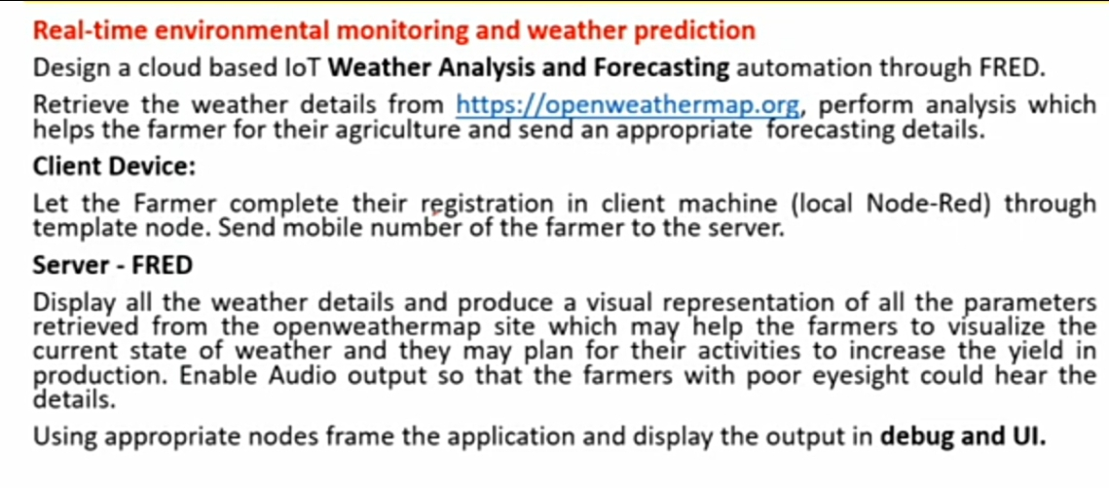

**Flow:**

**Client Side:**

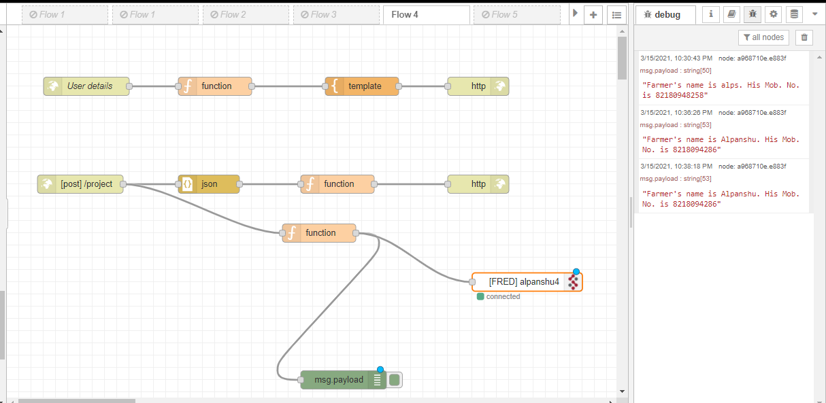

**Server Side:**

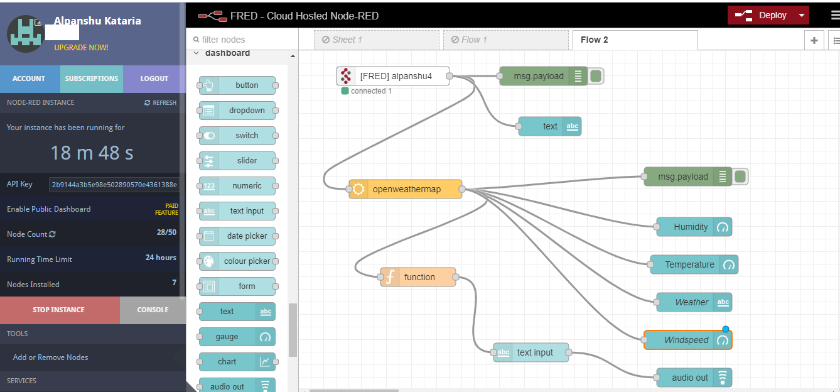

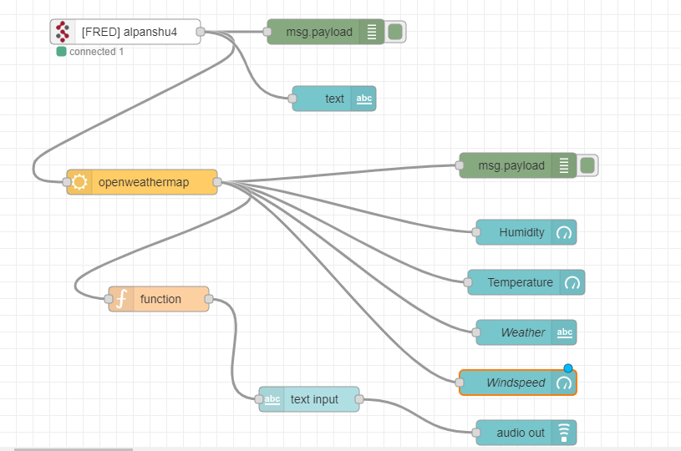

**Node:**

**Function to extract farmer’s mobile no.:**

msg.payload ="Farmer's name is " + msg.payload.farmer_first_name + ". His Mob. No. is " + msg.payload.Mob_No;  
return msg;

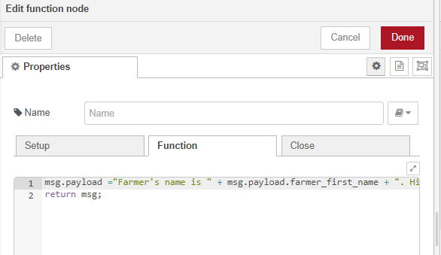

**Debug monitor:**

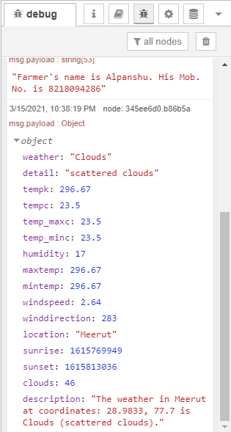

**Web Page:**

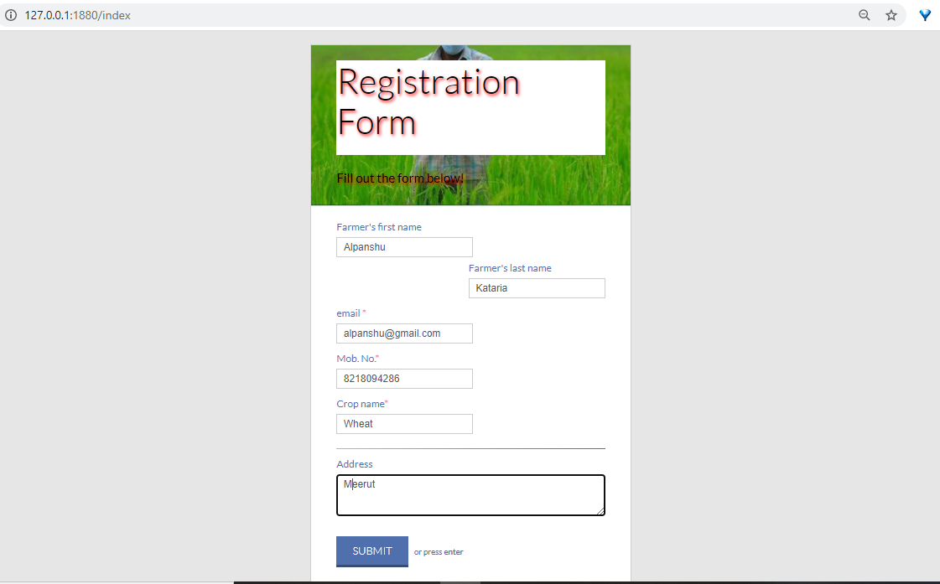

**Dashboard:**

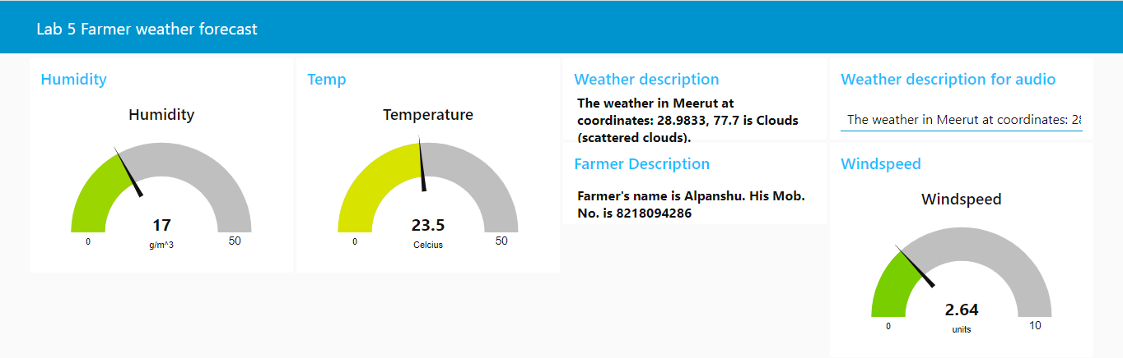

**HTML Code:**

<!DOCTYPE html>  
<html lang="en" >  
<head>  
<meta charset="UTF-8">  
<title>Registration Form</title>  
<meta name="viewport" content="width=device-width, initial-scale=1.0">  
<link rel="stylesheet" href="https://cdnjs.cloudflare.com/ajax/libs/normalize/5.0.0/normalize.min.css">  
<style>  
@import url(https://fonts.googleapis.com/css?family=Lato:300,400,700);  
 body {  
background-color: #e6e6e6;  
font-size: 100%;  
font-family: 'Lato', sans-serif;  
font-weight: 400;  
}  
div, textarea, input {  
-moz-box-sizing: border-box;  
-webkit-box-sizing: border-box;  
box-sizing: border-box;  
}  
.container {  
max-width: 510px;  
min-width: 324px;  
margin: 50px auto 0px;  
background-color: #fff;  
border: 1px solid #cfcfcf;  
border-bottom: 3px solid #ccc;  
}  
.row {  
width: 100%;  
margin: 0 0 1em 0;  
padding: 0 2.5em;  
}  
.row.header {  
padding: 1.5em 2.5em;  
border-bottom: 1px solid #ccc;  
background: url('https://images.indianexpress.com/2020/05/farmers-759.jpg?w=600') left -80px;  
color: #fff;  
}  
.row.body {  
padding: .5em 2.5em 1em;  
}  
.pull-right {  
float: right;  
}  
h1 {  
font-family: 'Lato', sans-serif;  
font-weight: 300;  
display: inline-block;  
font-weight: 100;  
 background-color: white;  
color: black;  
text-shadow: 2px 2px 5px red;  
font-size: 3.5em;  
border-bottom: 1px solid rgba(255, 255, 255, 0.3);  
margin: 0 0 0.1em 0;  
padding: 0 0 0.4em 0;  
}  
h3 {  
font-family: 'Lato', sans-serif;  
font-weight: 400;  
font-size: 1.25em;  
color: black;  
text-shadow: 2px 2px 5px red;  
margin: 1em 0 0.4em 0;  
}  
.btn {  
font-size: 1.0625em;  
display: inline-block;  
padding: 0.74em 1.5em;  
margin: 1.5em 0 0;  
color: #fff;  
border-width: 0 0 0 0;  
border-bottom: 5px solid;  
text-transform: uppercase;  
background-color: #b3b3b3;  
border-bottom-color: #8c8c8c;  
font-family: 'Lato', sans-serif;  
font-weight: 300;  
}  
.btn:hover {  
background-color: #bfbfbf;  
}  
.btn.btn-submit {  
background-color: #4f6fad;  
border-bottom-color: #374d78;  
}  
.btn.btn-submit:hover {  
background-color: #5f7db6;  
}  
form {  
max-width: 100%;  
 display: block;  
}  
form ul {  
margin: 0;  
padding: 0;  
list-style: none;  
}  
form ul li {  
margin: 0 0 0.25em 0;  
clear: both;  
display: inline-block;  
width: 100%;  
}  
form ul li:last-child {  
margin: 0;  
}  
form ul li p {  
margin: 0;  
padding: 0;  
float: left;  
}  
form ul li p.right {  
float: right;  
}  
form ul li .divider {  
margin: 0.5em 0 0.5em 0;  
border: 0;  
height: 1px;  
width: 100%;  
display: block;  
background-color: #4f6fad;  
background-image: linear-gradient(to right, #ee9cb4, #4f6fad);  
}  
form ul li .req {  
color: #ee9cb4;  
}  
form label {  
display: block;  
margin: 0 0 0.5em 0;  
color: #4f6fad;  
font-size: 1em;  
}  
 form input {  
margin: 0 0 0.5em 0;  
border: 1px solid #ccc;  
padding: 6px 10px;  
color: #555;  
font-size: 1em;  
}  
form textarea {  
border: 1px solid #ccc;  
padding: 6px 10px;  
width: 100%;  
color: #555;  
}  
form small {  
color: #4f6fad;  
margin: 0 0 0 0.5em;  
}  
@media only screen and (max-width: 480px) {  
.pull-right {  
float: none;  
}  
input {  
width: 100%;  
}  
label {  
width: 100%;  
display: inline-block;  
float: left;  
clear: both;  
}  
li, p {  
width: 100%;  
}  
input.btn {  
margin: 1.5em 0 0.5em;  
}  
h1 {  
font-size: 2.25em;  
}  
h3 {  
font-size: 1.125em;  
 }  
li small {  
display: none;  
}  
}  
</style>  
</head>  
<body>  
<!-- partial:index.partial.html -->  
<div class="container">  
<div class="row header">  
<h1>Registration Form &nbsp;</h1>  
<h3>Fill out the form below!</h3>  
</div>  
<div class="row body">  
<form method="post" action="/project">  
<ul>  
<li>  
<p class="left">  
<label for="farmer_first_name">Farmer's first name</label>  
<input type="text" name="farmer_first_name" placeholder="Alpanshu" />  
</p>  
<p class="pull-right">  
<label for="farmer_last_name">Farmer's last name</label>  
<input type="text" name="farmer_last_name" placeholder="Kataria" />  
</p>  
</li>  
<li>  
<p>  
<label for="email">email <span class="req">*</span></label>  
<input type="email" name="email" placeholder="alpanshu.kataria@gmail.com" />  
</p>  
</li>  
<li>  
<p>  
<label for="Mob_No">Mob. No.<span class="req">*</span></label>  
<input type="Mob_No" name="Mob_No" placeholder="Mob. No." />  
</p>  
</li>  
 <li>  
<p>  
<label for="Crop_name">Crop name<span class="req">*</span></label>  
<input type="Crop_name" name="Crop_name" placeholder="Crop_name" />  
</p>  
</li>  
<li><div class="divider"></div></li>  
<li>  
<label for="Address">Address</label>  
<textarea cols="46" rows="3" name="Address"></textarea>  
</li>  
 <li>  
 <input class="btn btn-submit" type="submit" value="Submit" />  
 <small>or press <strong>enter</strong></small>  
 </li>  
</ul>  
</form>  
</div>  
</div>  
<!-- partial -->  
</body>  
</html>

**Json Code for server side:**

[

{

"id": "25933a5b.3a6166",

"type": "fred in",

"z": "69e21e83.a54b5",

"name": "",

"server": "7776b2e1.dff46c",

"client": "",

"x": 150,

"y": 60,

"wires": [

[

"4ae7531c.6316ac",

"8bd0dce.5b6672",

"f45e682b.72dc28"

]

]

},

{

"id": "4ae7531c.6316ac",

"type": "debug",

"z": "69e21e83.a54b5",

"name": "",

"active": true,

"tosidebar": true,

"console": false,

"tostatus": false,

"complete": "false",

"statusVal": "",

"statusType": "auto",

"x": 390,

"y": 60,

"wires": []

},

{

"id": "8bd0dce.5b6672",

"type": "openweathermap",

"z": "69e21e83.a54b5",

"name": "",

"wtype": "current",

"lon": "",

"lat": "",

"city": "Meerut",

"country": "India",

"language": "en",

"x": 170,

"y": 240,

"wires": [

[

"345ee6d0.b86b5a",

"a881f773.172528",

"3f6fdc8.eb33524",

"a4bf0069.10599",

"7fdd709f.833ba",

"8af02bbe.4c8588"

]

]

},

{

"id": "345ee6d0.b86b5a",

"type": "debug",

"z": "69e21e83.a54b5",

"name": "",

"active": true,

"tosidebar": true,

"console": false,

"tostatus": false,

"complete": "false",

"statusVal": "",

"statusType": "auto",

"x": 620,

"y": 220,

"wires": []

},

{

"id": "a881f773.172528",

"type": "ui_gauge",

"z": "69e21e83.a54b5",

"name": "",

"group": "4383afd5.dce02",

"order": 0,

"width": 0,

"height": 0,

"gtype": "gage",

"title": "Humidity",

"label": "g/m^3",

"format": "{{msg.payload.humidity}}",

"min": 0,

"max": "50",

"colors": [

"#00b500",

"#e6e600",

"#ca3838"

],

"seg1": "",

"seg2": "",

"x": 630,

"y": 300,

"wires": []

},

{

"id": "e631a12d.2544",

"type": "ui_audio",

"z": "69e21e83.a54b5",

"name": "",

"group": "ebdef8d9.d5eb18",

"voice": "Microsoft David Desktop - English (United States)",

"always": "",

"x": 630,

"y": 540,

"wires": []

},

{

"id": "7fdd709f.833ba",

"type": "function",

"z": "69e21e83.a54b5",

"name": "",

"func": "msg.payload=msg.payload.description;\nreturn msg;",

"outputs": 1,

"noerr": 0,

"initialize": "",

"finalize": "",

"x": 190,

"y": 380,

"wires": [

[

"2aaca307.42422c"

]

]

},

{

"id": "3f6fdc8.eb33524",

"type": "ui_gauge",

"z": "69e21e83.a54b5",

"name": "",

"group": "e83d5353.c76f8",

"order": 1,

"width": 0,

"height": 0,

"gtype": "gage",

"title": "Temperature",

"label": "Celcius",

"format": "{{msg.payload.tempc}}",

"min": 0,

"max": "50",

"colors": [

"#00b500",

"#e6e600",

"#ca3838"

],

"seg1": "",

"seg2": "",

"x": 630,

"y": 360,

"wires": []

},

{

"id": "a4bf0069.10599",

"type": "ui_text",

"z": "69e21e83.a54b5",

"group": "2c23e1af.b0e4fe",

"order": 1,

"width": 0,

"height": 0,

"name": "Weather",

"label": "",

"format": "{{msg.payload.description}}",

"layout": "row-spread",

"x": 630,

"y": 420,

"wires": []

},

{

"id": "2aaca307.42422c",

"type": "ui_text_input",

"z": "69e21e83.a54b5",

"name": "",

"label": "",

"tooltip": "",

"group": "5937532b.bc790c",

"order": 1,

"width": 0,

"height": 0,

"passthru": true,

"mode": "text",

"delay": 300,

"topic": "topic",

"x": 370,

"y": 500,

"wires": [

[

"e631a12d.2544"

]

]

},

{

"id": "8af02bbe.4c8588",

"type": "ui_gauge",

"z": "69e21e83.a54b5",

"name": "Windspeed",

"group": "191bb3b7.81435c",

"order": 1,

"width": 0,

"height": 0,

"gtype": "gage",

"title": "Windspeed",

"label": "m/sec",

"format": "{{msg.payload.windspeed}}",

"min": 0,

"max": 10,

"colors": [

"#00b500",

"#e6e600",

"#ca3838"

],

"seg1": "",

"seg2": "",

"x": 620,

"y": 480,

"wires": []

},

{

"id": "f45e682b.72dc28",

"type": "ui_text",

"z": "69e21e83.a54b5",

"group": "c6963855.5a1dd8",

"order": 0,

"width": 0,

"height": 0,

"name": "",

"label": "",

"format": "{{msg.payload}}",

"layout": "row-spread",

"x": 400,

"y": 140,

"wires": []

},

{

"id": "7776b2e1.dff46c",

"type": "fred-server",

"endpoint": "alpanshu4",

"private": false,

"wholemsg": "true"

},

{

"id": "4383afd5.dce02",

"type": "ui_group",

"name": "Humidity",

"tab": "7188d184.8a82f",

"order": 2,

"disp": true,

"width": "6",

"collapse": false

},

{

"id": "ebdef8d9.d5eb18",

"type": "ui_group",

"name": "Audio",

"tab": "7188d184.8a82f",

"order": 3,

"disp": true,

"width": "6",

"collapse": false

},

{

"id": "e83d5353.c76f8",

"type": "ui_group",

"name": "Temp",

"tab": "7188d184.8a82f",

"order": 4,

"disp": true,

"width": "6",

"collapse": false

},

{

"id": "2c23e1af.b0e4fe",

"type": "ui_group",

"name": "Weather description",

"tab": "7188d184.8a82f",

"order": 5,

"disp": true,

"width": "6",

"collapse": false

},

{

"id": "5937532b.bc790c",

"type": "ui_group",

"name": "Weather description for audio",

"tab": "7188d184.8a82f",

"order": 7,

"disp": true,

"width": "6",

"collapse": false

},

{

"id": "191bb3b7.81435c",

"type": "ui_group",

"name": "Windspeed",

"tab": "7188d184.8a82f",

"order": 8,

"disp": true,

"width": "6",

"collapse": false

},

{

"id": "c6963855.5a1dd8",

"type": "ui_group",

"name": "Farmer Description",

"tab": "7188d184.8a82f",

"order": 7,

"disp": true,

"width": "6",

"collapse": false

},

{

"id": "7188d184.8a82f",

"type": "ui_tab",

"name": "Lab 5 Farmer weather forecast",

"icon": "dashboard",

"order": 3,

"disabled": false,

"hidden": false

}

]

**Json code for c,lient side:**

[

{

"id": "6c8e347a.7d492c",

"type": "http in",

"z": "492e57b6.69bf38",

"name": "User details",

"url": "/index",

"method": "get",

"upload": false,

"swaggerDoc": "",

"x": 130,

"y": 100,

"wires": [

[

"c6c45c02.04281"

]

]

},

{

"id": "aaaf7d78.be4a1",

"type": "http response",

"z": "492e57b6.69bf38",

"name": "",

"statusCode": "",

"headers": {},

"x": 770,

"y": 100,

"wires": []

},

{

"id": "c6c45c02.04281",

"type": "function",

"z": "492e57b6.69bf38",

"name": "",

"func": "msg.url=\"index\";\nreturn msg;",

"outputs": 1,

"noerr": 0,

"initialize": "",

"finalize": "",

"x": 340,

"y": 100,

"wires": [

[

"da1f896d.0f1c98"

]

]

},

{

"id": "da1f896d.0f1c98",

"type": "template",

"z": "492e57b6.69bf38",

"name": "",

"field": "payload",

"fieldType": "msg",

"format": "html",

"syntax": "mustache",

"template": "<!DOCTYPE html>\n<html lang=\"en\" >\n<head>\n<meta charset=\"UTF-8\">\n<title>Registration Form</title>\n<meta name=\"viewport\" content=\"width=device-width, initial-scale=1.0\">\n<link rel=\"stylesheet\" href=\"https://cdnjs.cloudflare.com/ajax/libs/normalize/5.0.0/normalize.min.css\">\n<style>\n@import url(https://fonts.googleapis.com/css?family=Lato:300,400,700);\n body {\nbackground-color: #e6e6e6;\nfont-size: 100%;\nfont-family: 'Lato', sans-serif;\nfont-weight: 400;\n}\ndiv, textarea, input {\n-moz-box-sizing: border-box;\n-webkit-box-sizing: border-box;\nbox-sizing: border-box;\n}\n.container {\nmax-width: 510px;\nmin-width: 324px;\nmargin: 50px auto 0px;\nbackground-color: #fff;\nborder: 1px solid #cfcfcf;\nborder-bottom: 3px solid #ccc;\n}\n.row {\nwidth: 100%;\nmargin: 0 0 1em 0;\npadding: 0 2.5em;\n}\n.row.header {\npadding: 1.5em 2.5em;\nborder-bottom: 1px solid #ccc;\nbackground: url('https://images.indianexpress.com/2020/05/farmers-759.jpg?w=600') left -80px;\ncolor: #fff;\n}\n.row.body {\npadding: .5em 2.5em 1em;\n}\n.pull-right {\nfloat: right;\n}\nh1 {\nfont-family: 'Lato', sans-serif;\nfont-weight: 300;\ndisplay: inline-block;\nfont-weight: 100;\n background-color: white;\ncolor: black;\ntext-shadow: 2px 2px 5px red;\nfont-size: 3.5em;\nborder-bottom: 1px solid rgba(255, 255, 255, 0.3);\nmargin: 0 0 0.1em 0;\npadding: 0 0 0.4em 0;\n}\nh3 {\nfont-family: 'Lato', sans-serif;\nfont-weight: 400;\nfont-size: 1.25em;\ncolor: black;\ntext-shadow: 2px 2px 5px red;\nmargin: 1em 0 0.4em 0;\n}\n.btn {\nfont-size: 1.0625em;\ndisplay: inline-block;\npadding: 0.74em 1.5em;\nmargin: 1.5em 0 0;\ncolor: #fff;\nborder-width: 0 0 0 0;\nborder-bottom: 5px solid;\ntext-transform: uppercase;\nbackground-color: #b3b3b3;\nborder-bottom-color: #8c8c8c;\nfont-family: 'Lato', sans-serif;\nfont-weight: 300;\n}\n.btn:hover {\nbackground-color: #bfbfbf;\n}\n.btn.btn-submit {\nbackground-color: #4f6fad;\nborder-bottom-color: #374d78;\n}\n.btn.btn-submit:hover {\nbackground-color: #5f7db6;\n}\nform {\nmax-width: 100%;\n display: block;\n}\nform ul {\nmargin: 0;\npadding: 0;\nlist-style: none;\n}\nform ul li {\nmargin: 0 0 0.25em 0;\nclear: both;\ndisplay: inline-block;\nwidth: 100%;\n}\nform ul li:last-child {\nmargin: 0;\n}\nform ul li p {\nmargin: 0;\npadding: 0;\nfloat: left;\n}\nform ul li p.right {\nfloat: right;\n}\nform ul li .divider {\nmargin: 0.5em 0 0.5em 0;\nborder: 0;\nheight: 1px;\nwidth: 100%;\ndisplay: block;\nbackground-color: #4f6fad;\nbackground-image: linear-gradient(to right, #ee9cb4, #4f6fad);\n}\nform ul li .req {\ncolor: #ee9cb4;\n}\nform label {\ndisplay: block;\nmargin: 0 0 0.5em 0;\ncolor: #4f6fad;\nfont-size: 1em;\n}\n form input {\nmargin: 0 0 0.5em 0;\nborder: 1px solid #ccc;\npadding: 6px 10px;\ncolor: #555;\nfont-size: 1em;\n}\nform textarea {\nborder: 1px solid #ccc;\npadding: 6px 10px;\nwidth: 100%;\ncolor: #555;\n}\nform small {\ncolor: #4f6fad;\nmargin: 0 0 0 0.5em;\n}\n@media only screen and (max-width: 480px) {\n.pull-right {\nfloat: none;\n}\ninput {\nwidth: 100%;\n}\nlabel {\nwidth: 100%;\ndisplay: inline-block;\nfloat: left;\nclear: both;\n}\nli, p {\nwidth: 100%;\n}\ninput.btn {\nmargin: 1.5em 0 0.5em;\n}\nh1 {\nfont-size: 2.25em;\n}\nh3 {\nfont-size: 1.125em;\n }\nli small {\ndisplay: none;\n}\n}\n</style>\n</head>\n<body>\n<!-- partial:index.partial.html -->\n<div class=\"container\">\n<div class=\"row header\">\n<h1>Registration Form &nbsp;</h1>\n<h3>Fill out the form below!</h3>\n</div>\n<div class=\"row body\">\n<form method=\"post\" action=\"/project\">\n<ul>\n<li>\n<p class=\"left\">\n<label for=\"farmer_first_name\">Farmer's first name</label>\n<input type=\"text\" name=\"farmer_first_name\" placeholder=\"Alpanshu\" />\n</p>\n<p class=\"pull-right\">\n<label for=\"farmer_last_name\">Farmer's last name</label>\n<input type=\"text\" name=\"farmer_last_name\" placeholder=\"Kataria\" />\n</p>\n</li>\n<li>\n<p>\n<label for=\"email\">email <span class=\"req\">*</span></label>\n<input type=\"email\" name=\"email\" placeholder=\"alpanshu.kataria@gmail.com\" />\n</p>\n</li>\n<li>\n<p>\n<label for=\"Mob_No\">Mob. No.<span class=\"req\">*</span></label>\n<input type=\"Mob_No\" name=\"Mob_No\" placeholder=\"Mob. No.\" />\n</p>\n</li>\n <li>\n<p>\n<label for=\"Crop_name\">Crop name<span class=\"req\">*</span></label>\n<input type=\"Crop_name\" name=\"Crop_name\" placeholder=\"Crop_name\" />\n</p>\n</li>\n<li><div class=\"divider\"></div></li>\n<li>\n<label for=\"Address\">Address</label>\n<textarea cols=\"46\" rows=\"3\" name=\"Address\"></textarea>\n</li>\n <li>\n <input class=\"btn btn-submit\" type=\"submit\" value=\"Submit\" />\n <small>or press <strong>enter</strong></small>\n </li>\n</ul>\n</form>\n</div>\n</div>\n<!-- partial -->\n</body>\n</html>",

"output": "str",

"x": 580,

"y": 100,

"wires": [

[

"aaaf7d78.be4a1"

]

]

},

{

"id": "cd86cfa2.eca25",

"type": "http in",

"z": "492e57b6.69bf38",

"name": "",

"url": "/project",

"method": "post",

"upload": false,

"swaggerDoc": "",

"x": 120,

"y": 260,

"wires": [

[

"2894836e.939d4c",

"7f5f2607.a0a468"

]

]

},

{

"id": "53e1226.49800dc",

"type": "function",

"z": "492e57b6.69bf38",

"name": "",

"func": "return msg;",

"outputs": 1,

"noerr": 0,

"initialize": "",

"finalize": "",

"x": 540,

"y": 260,

"wires": [

[

"9b74c6a7.fd8a28"

]

]

},

{

"id": "9b74c6a7.fd8a28",

"type": "http response",

"z": "492e57b6.69bf38",

"name": "",

"statusCode": "",

"headers": {},

"x": 770,

"y": 260,

"wires": []

},

{

"id": "2894836e.939d4c",

"type": "json",

"z": "492e57b6.69bf38",

"name": "",

"property": "payload",

"action": "",

"pretty": false,

"x": 330,

"y": 260,

"wires": [

[

"53e1226.49800dc"

]

]

},

{

"id": "a968710e.e883f",

"type": "debug",

"z": "492e57b6.69bf38",

"name": "",

"active": true,

"tosidebar": true,

"console": false,

"tostatus": false,

"complete": "false",

"statusVal": "",

"statusType": "auto",

"x": 550,

"y": 580,

"wires": []

},

{

"id": "7f5f2607.a0a468",

"type": "function",

"z": "492e57b6.69bf38",

"name": "",

"func": "msg.payload =\"Farmer's name is \" + msg.payload.farmer_first_name + \". His Mob. No. is \" + msg.payload.Mob_No;\nreturn msg;",

"outputs": 1,

"noerr": 0,

"initialize": "",

"finalize": "",

"x": 510,

"y": 340,

"wires": [

[

"a968710e.e883f",

"8328dc69.be328"

]

]

},

{

"id": "8328dc69.be328",

"type": "fred out",

"z": "492e57b6.69bf38",

"name": "",

"server": "",

"client": "ba178cc8.608cf",

"x": 850,

"y": 420,

"wires": []

},

{

"id": "ba178cc8.608cf",

"type": "fred-client",

"endpoint": "alpanshu4",

"private": false,

"username": "alps",

"wholemsg": "false"

}

]